Fish Names Can Be Confusing

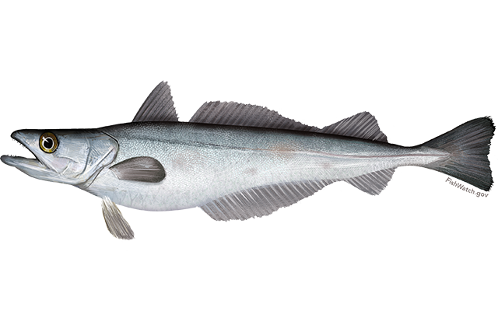
Listed here are common fish that have the same name but are different fish depending where you came from. This list is intended to educate us anglers so that we know what the fish is despite having the same name as another fish. Information and pictures have been copied from various fish “council” and state fisheries sources on the internet. I have tried to keep all signatures to give credit to the artists.

Whiting and Kingfish
- Northern Atlantic whiting are “silver hake and are caught in deeper water when Cod fishing when there were cod. Also Known As (Whiting, Atlantic hake, New England hake)
- Southern whiting are also called kingfish. Southern kingfish are inshore bottomfish with elongated bodies and an inferior or downward pointing mouth with the snout extending beyond the mouth. They have a single rigid barbel under the chin.
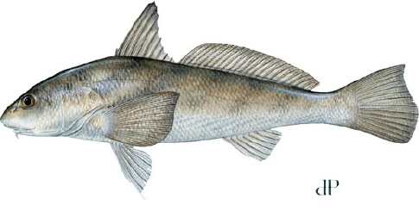
Southern kingfish are relatively small, reaching a maximum length of about 16 inches and a weight of about 2.5 pounds. Most fish caught by anglers are somewhat smaller, typically about 12" in length and one-half pound. Southern kingfish are members of the drum family, which includes spotted sea trout and red drum.
Southern kingfish are also called sea mullet in in NC and are caught on shrimp pieces. Real mullet are vegetarians.
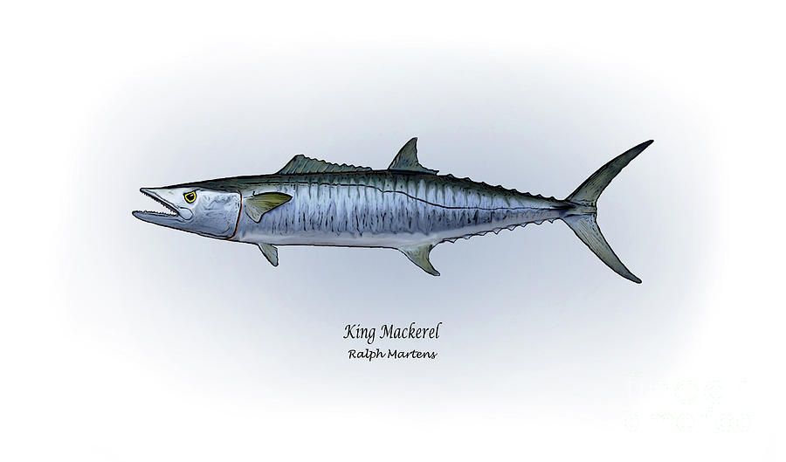
The Southern Whiting (Kingfish) should not be confused with King Mackerel which are sometimes also just called kingfish. The king mackerel is a much larger fish, typically encountered from 5 to 14 kg (30 lb), but is known to exceed 40 kg (90 lb). The King Mackerel would have no trouble eating a southern kingfish. The King Mackerel’s entire body is covered with very small, hardly visible, loosely attached scales.

Fish Called Ling

Saltwater Northern Ling
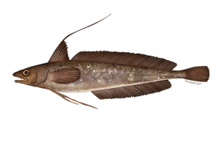
Saltwater Northern ling are red hake and are found where whiting are found. Red hake are a member of the cod family. Region: New England and Mid Atlantic
They do not grow as large as white hake and normally reach a maximum size of 50 centimeters (20 inches) and 2 kilograms (4.4 pounds).
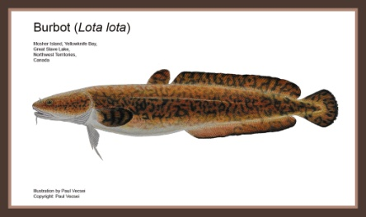
Fresh water burbot

Burbot are also called ling. It is the only freshwater representative of the Cod family. They live in cold, deep lakes. You either love them or hate them. Michigan folks are especially fond of them. They taste like lobster and there are limited commercial fisheries for this species throughout the world. They are present in parts of Northern Europe and widespread throughout Russia.

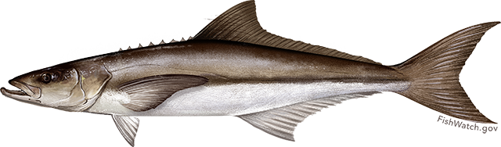
Salt water cobia

Salt water cobia are also called ling in the northern Gulf of Mexico or lemonfish in Louisiana
Attaining emonfisha maximum length of 2 m (78 in) and maximum weight of 78 kg (172 lb),

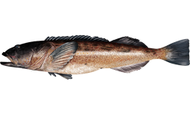
This fish is considered to be one of the most suitable candidates for warm, open-water marine fish aquaculture in the world. Its rapid growth rate and the high quality of the flesh could make it one of the most important marine fish for future aquaculture production. It was featured on an American Iron Chefs Contest.

LingCod
The lingcod or ling cod is a fish of the greenling family. It is native to the North American west coast from the Gulf of Alaska to Baja California, Mexico. It has been observed up to a size of 152 centimetres (60 in) and a weight of 59 kilograms (130 lb). It is spotted in various shades of grey. The lingcod is a popular eating fish, and is thus prized by anglers. Though not closely related to either Ling or cod, the name "lingcod" originated because it somewhat resembles those fish.

Sheepshead
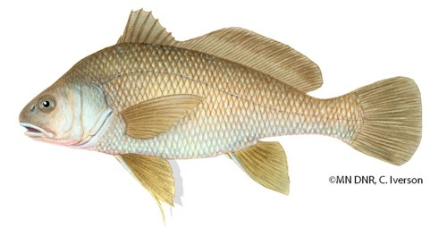
Great Lakes Sheepshead
The freshwater sheepshead is a drum and a relative of the saltwater redfish. The freshwater drum is a fish known for its noise. Males make a grunting or rumbling sound during the breeding season, which is thought to attract females. The freshwater sheepshead is considered a trash fish. It is edible if you keep and prepare them properly but few people eat them.
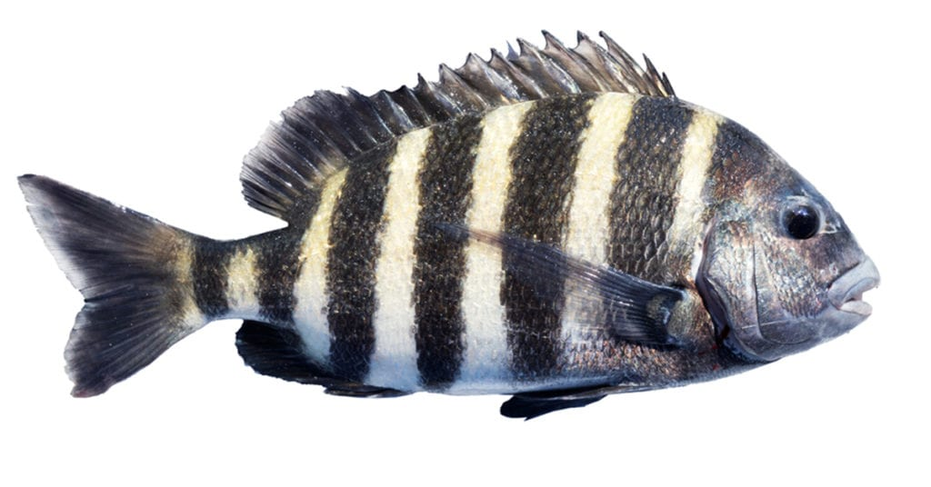
Salt Water Sheepshead
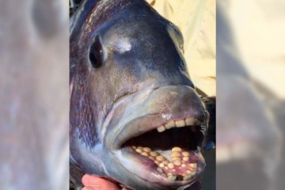
The saltwater sheepshead is considered fine tablefare in Florida. Sheepshead is a marine fish that grows to 76 cm (30 in), but commonly reaches 30 to 50 cm (10 to 20 in). It is deep and compressed in body shape, with five or six dark bars on the side of the body over a gray background. It has sharp dorsal spines. Its diet consists of oysters, clams, and other bivalves, and barnacles, fiddler crabs, and other crustacians. It has a hard mouth, with several rows of stubby teeth – the frontal ones closely resembling human teeth – which help crush the shells of prey. The sheepshead is found in coastal waters along the western Atlantic, from Nova Scotia to Brazil, but the greatest concentration is around southwest Florida. Although the Sheepshead section of Brooklyn, in New York City, was named after the fish, it is now rarely found that far north. However they just recently started to return to the area in small numbers, with a few being caught in the Jamaica Bay and on the Rockaway Reef.

In Florida, the winter months are prime sheepshead time since the larger fish gather for the spawn.

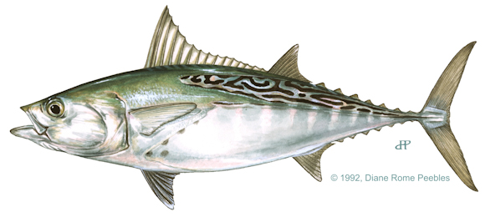
Little Tunny: Euthynnus alletteratus (Tuna not Mackerel)

Appearance:
Also known as bonito and blue bonito. False albacore
Broken, wavy, diagonal dark stripes on back
3 to 7 dark spots under each pectoral fin
Lack dark stripes on belly
Relatively short pectoral fins

Similar Species: Atlantic bonito, S. sarda (lack spots below pectoral fin; dark stripes on back are mostly straight) Dark red meat edible if bled and iced immediately
Size: Up to 48 inches

This is an Atlantic Bonito (Mackerel not tuna) Atlantic Bonito: Sarda sarda
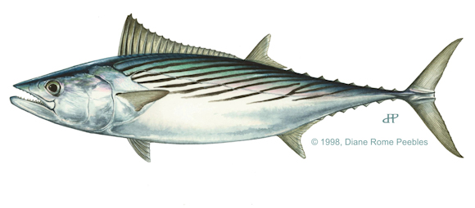
Appearance:
Also known as true bonito and northern bonito. Atlantic bonito
Mostly straight, diagonal stripes on back
Dark blue color on back and upper sides
Lack dark stripes on belly
Relatively short pectoral fins
Similar Species: Little tunny, E. alletteratus (wavy dark stripes on back; 4 to 5 dark spots below pectoral fin); and skipjack tuna, K. pelamis (stripes on lower sides, not on back)
Edibility good if bled and iced immediately
Size: Up to 36 inches

Flounders: One Name; Two Totally Different Fish

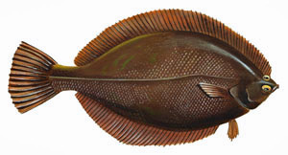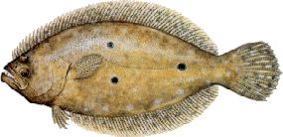

Right-eyed | Eye Direction | Left-eyed
Winter Flounder (NY, NJ, Mass, Maine etc.)  Numbers are greatly reduced at present.  Similar fish are soles and plaice (in Europe) | Northern Range | Summer Flounder (Fluke) (NY, NJ, Mass, Maine etc.)  See Next Page for more pictures of flounders with teeth which are relatives of the southern flounder
There are no fish similar to Right eyed flounder in this area that I know of. | Southern Range | NC to Florida and along Gulf of Mexico mainly Southern Flounder with some Gulf Flounder
~October to April | NY, NJ Inshore Period | April-May through October in NJ, NY
No teeth, small mouth | Teeth? | Has Teeth scientific name “Dentatis”
Smaller fish 12” min size to keep | Size | Much larger fish >18 “ size to keep
Swims and feeds on stationary prey: worms, clam tongues etc | Feeding Method | Settles into sandy bottom and ambushes small fish and crustaceans that pass by
Solid Brown matching dark bottom | Coloration | Mottled camouflage for blending with sand bottom. Pattern changes with sand coloration..kind of chameleon move.

Link: http://portal.ncdenr.org/c/document_library/get_file?uuid=636f2c2d-c6fd-4ef9-b561-6e8064284c0e&groupId=38337

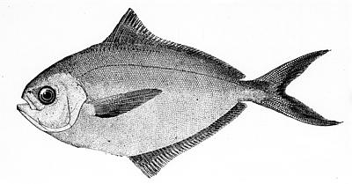
Butterfish A Tangled Tale of Names

Butterfish can refer to a specific fish, a fish preparation, or a regional name for a fish with a different name.

In NY/NJ area, butterfish was the name for popular bluefish bait. They are relatively small about 5 to 6 inches, with 12 inch maximum size. They are reported to be decent table fare but we never tried to cook and eat any. We bought frozen blocks of whole fish used for cut bait.

In Florida around The Villages, butterfish are listed on many restaurant menus. These butterfish are Escolar a deep water (600 t0 3000 ft) fish found in temperate waters around the world. It is succulent and in a culinary class with other deep sea fish caught as by catch on long lines such as orange ruffy, Chilean Seabass (Patagonian Toothfish), and Sablefish (Black Cod), etc. It is relatively inexpensive, sustainable, and usually caught as a by catch on long lines fished for tuna.

Sounds Great…BUT Escolar can cause Kerriorhoea because the wax esters in the flesh of the fish pool up in your intestine. The wax ester gives Escolar its dreamy velvety texture. Unfortunately is not digestible by humans and causes severe gastronomical distress in some people. The distress has been described as urgent violent orange diarrhea.
Escolar is banned outright in Japan and Italy. The EEU requires escolar to be sold only in packaged form with health warnings. Hawaii had restrictions but dropped them. Hawaii is a main producer of Escolar…surprise, surprise

Beware, there are other names used for Escolar such as white tuna (especially in sushi), rudderfish, and Hawaiian walu.

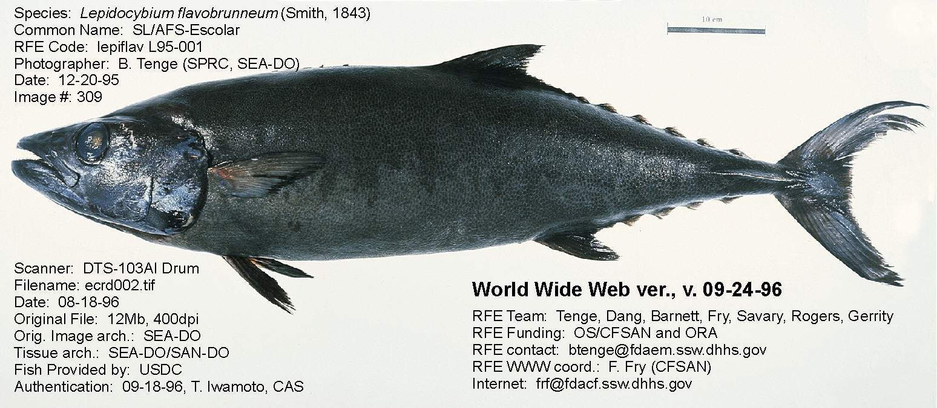

Butterfish as in a Type of Fish Preparation.

There are recipes for various types of butterfish misoyaki using Japanese marinades. Often the fish used is Pacific Black “Cod” or sablefish.

Salmon Names

Pacific Salmon also stocked in Great Lakes
Alaska Name | Other Names | Years to Spawn | Typical Size, lbs | Max Size pounds
Chinook | King | 3 to 6 | 30 | >100
Coho | Silver | 2 to 7 but 3 to 4 is avg | 18 | >30
Keta (as used in Publix ads) | Chum or Dog | 3 to 5 | 7 to 16 | 30
Sockeye | Red | 3 to 5 | 9 | 15
Humpy (from Russian) | Pink | 2 | 3 to 5 | 15
Kokanee  Natural Spawning in western US i.e. Oregon | Landlocked Sockeye | 4 if suitable waters exist. Often stocked fish not wild in PA. | 1

