The Villages Deep Sea Fishing Club
www.deepseafishingclub.org

Welcome to The Villages Deep Sea Fishing Club!
The Fishing Club meets on the first Monday of the month at the Everglades Rec Center. The doors will open at 6:00 PM and the meeting will start at 6:30 PM.
Club Officers:
President: Ken Jagodzinski Vice-President: Gaylon Thompson
386-986-7655 443-745-5706
VillagesDSFC@gmail.com gthom203@gmail.com
​Treasurer: Steve Newman Secretary: David Eoff
610-458-0359 406-386-0844
buddyjnewman@gmail.com eoff_david@yahoo.com

Social Media Director and webmaster: Al Anderson
716-397-5353
dsfcpictures@gmail.com
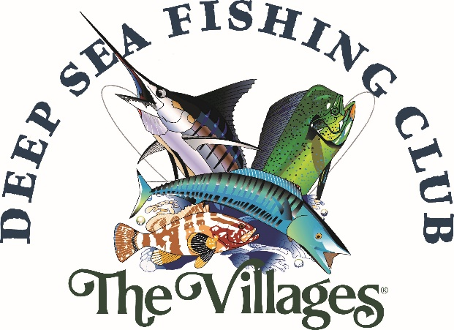
Our Club’s Purpose:
The purpose of The Club is to provide its members with the opportunity to participate in the many, varied activities of saltwater fishing available to us in a safe, legal, and skilled manner at a reasonable cost. To encourage sociability while enhancing camaraderie of those interested in fishing; and to share skills, talents, and knowledge of fishing in promoting good sportsmanship while protecting the environment.
The best way to discover all that the DSFC club offers is to visit our website and scroll through its pages. You can find out what fishing trips are currently offered, how to book a trip, how to pay and who to contact for more details. From finding out more about each Captain, their boats, target fish, fishing gear, etc. to accessing current FL and national regulations; to reading the latest monthly newsletter; to even getting fish recipes – all of this is on the website… and more.
www.deepseafishingclub.org
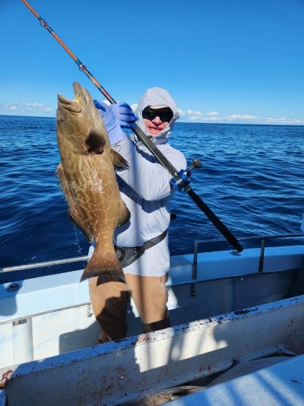 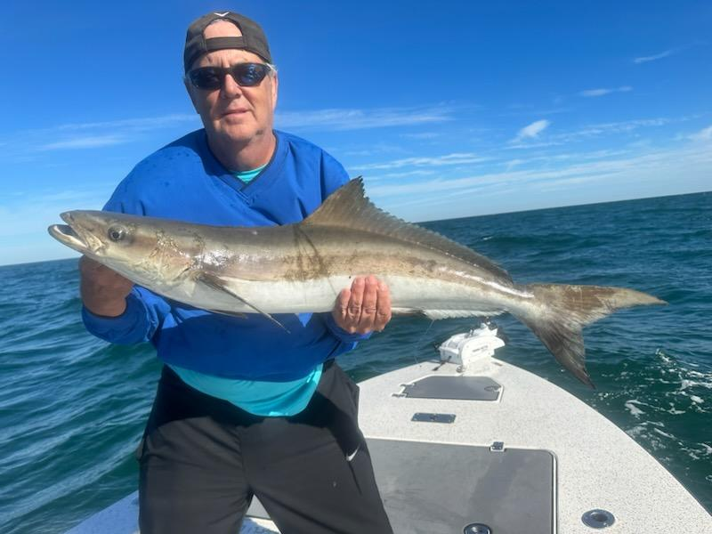 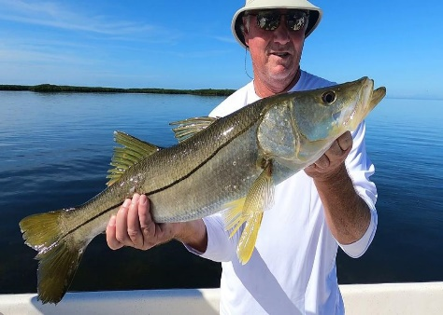

Member comments, trip reviews, pictures, etc. are best shared on our Facebook page. You may post them yourself or send them to dsfcpictures@gmail.com to be posted for you. If you send pictures, please include the trip and date and some context.
Go to Facebook and search for “deep sea fishing club” to access our page.
Link to face book page
If you are not familiar with fishing the central FL coasts… that’s OK – you can find out all you need to know about the fish to catch, when to catch them, # of fishermen per trip and the gear used at our webpage.
Keep in mind, you can sign up for any available trip by yourself – you don’t need to find other fishermen to fill the trip. Just sign up for the trip you want, pay the trip fee and wait to see if the trip fills. If it does you are “good to go”, if not your fee will be refunded or credited towards a future trip. If you get on a trip, usually the day before the coordinator will inform you of the launch marina, car pool arrangements, times and what to bring (and not bring). Usually, the only extra cost is the tip (normally 20%).
If you cannot make the trip that you signed up for, it is your responsibility to get another member to take your place on that trip. In most cases, contact the coordinator responsible for that trip and ask for help. If unable to find a replacement, you will forfeit your money.

CHARTER TRIP PAYMENTS – Payments for all charters are due at the time of booking. NO EXCEPTIONS.
Payment can be made in person at a Club meeting. As an alternative, after informing the coordinator of your intentions, members can mail payments to the following:
include Capt’s. name and trip date.
The Villages DSFC
% Steve Newman
P.O. Box 277
Oxford, FL 34484

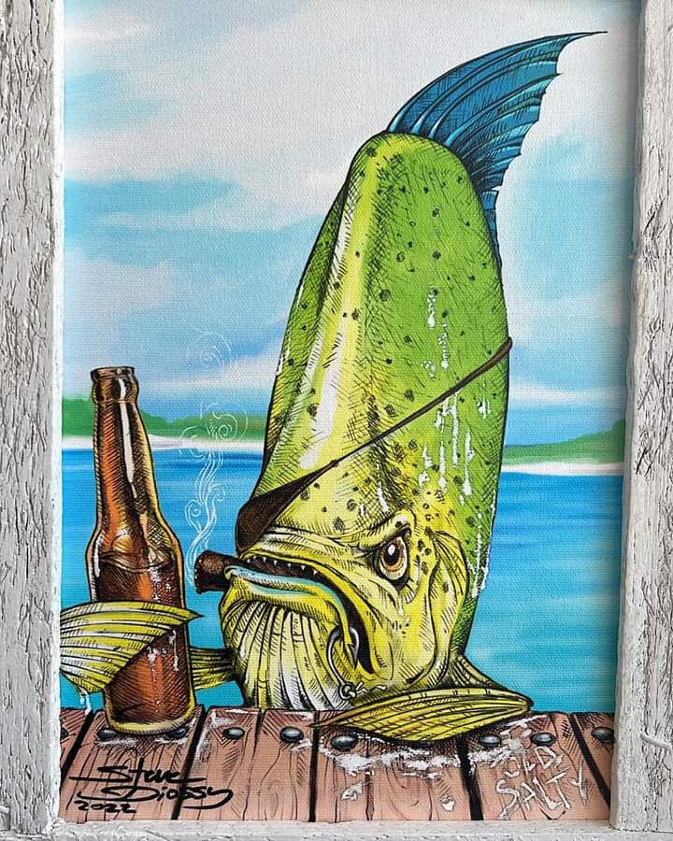 LET’S GO FISHIN’!

